LAB5 Report

Below screenshots represents the UI of the opensource game that I selected.

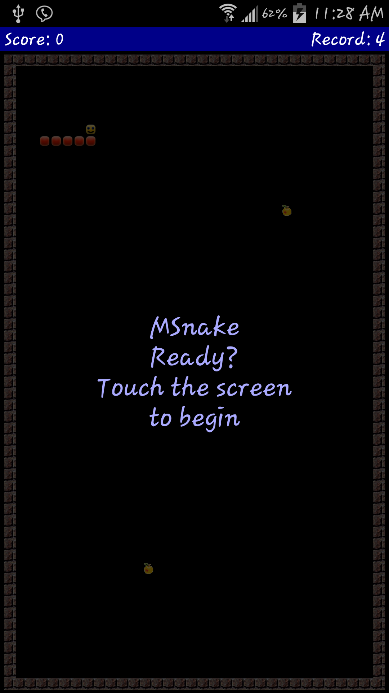

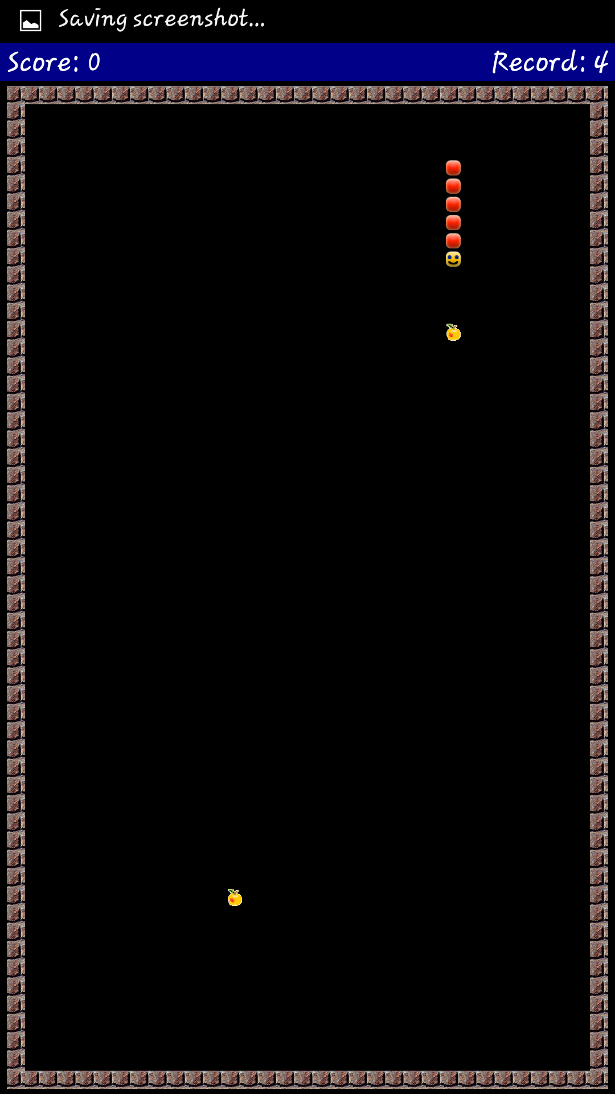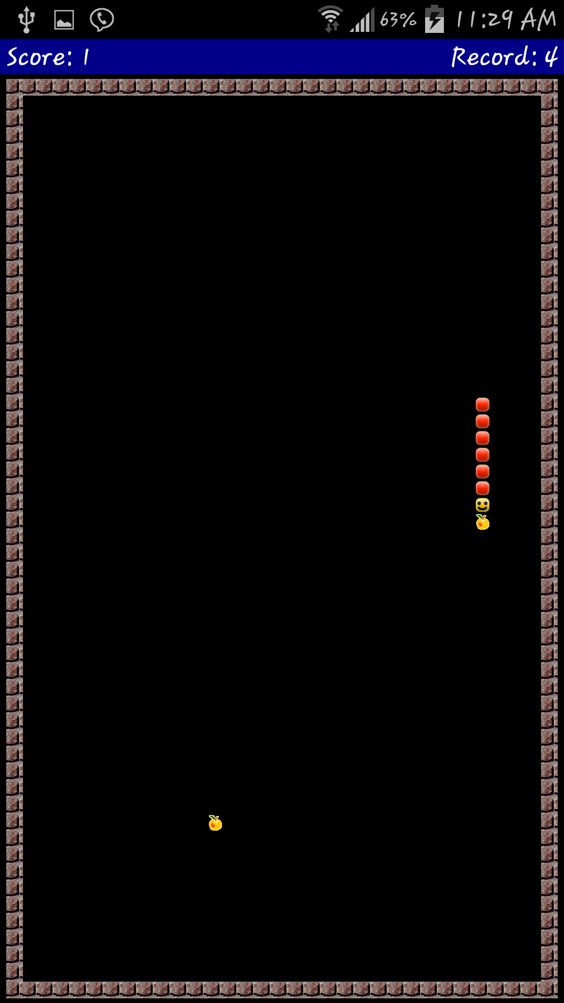

Below screenshot represents the changes I made to the android code.

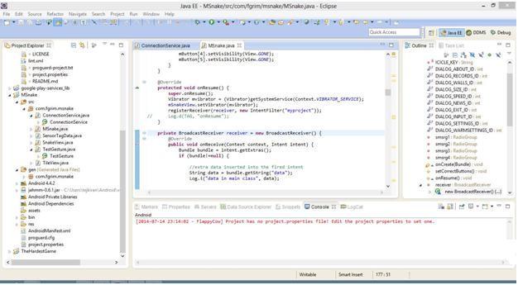

In the above screenshot I have created a new intent for the register receiver in on Resume event.

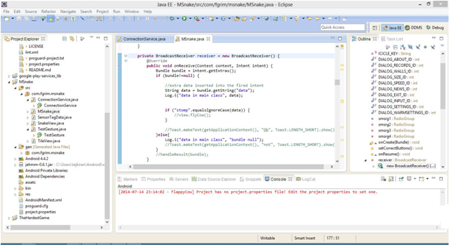

In the above screenshot I have created broadcast receiver class as shown in tutorials.

I have edited the code and tried with samsung s4 device. When I run the app with bluetooth on it got crashed. When I use the app without bluetooth app is working. And in S4 I was unable to broadcast events to other activities as mentioned in turuorials.